Ex.No.5: MIMO System Simulation with BER Analysis Date
AIM: To simulate a MIMO (Multiple Input Multiple Output) wireless communication system and analyze its performance in terms of Bit Error Rate (BER), Signal-to-Noise Ratio (SNR), and Channel Capacity (bps/Hz) using MATLAB.
Procedure
1. Define the MIMO system configuration (e.g., number of transmit and receive antennas such as 2×2 or 4×4).
2. Generate random binary data bits to represent the transmitted signal. 3. Modulate the bits using a digital modulation scheme (e.g., BPSK or QPSK). 4. Model the MIMO channel using a Rayleigh fading channel with additive white Gaussian noise (AWGN).
5. Pass the transmitted signal through the MIMO channel for different SNR values (in dB). 6. At the receiver, apply detection techniques (e.g., Zero-Forcing or Maximum Likelihood detection).
7. Demodulate the received signal to recover transmitted bits.
8. Compute Bit Error Rate (BER) by comparing transmitted and received bits. 9. Calculate Channel Capacity (bps/Hz) using SNR and MIMO capacity formula. 10. Plot BER vs SNR and Capacity vs SNR graphs for performance analysis.
Objective 1 Matlab Code and Output:
clc;
clear;
close all;
SNR_dB = 0:2:20;
SNR = 10.^(SNR_dB/10);
Nt = 2; Nr = 2;
BER = zeros(1,length(SNR));
for i = 1:length(SNR)

bits = randi([0 1],10000,1);
symbols = 2*bits-1;

H = (randn(Nr,Nt) + 1j*randn(Nr,Nt))/sqrt(2);
noise = (randn(Nr,10000) + 1j*randn(Nr,10000))/sqrt(2*SNR(i));
tx = H(1,1)*symbols' + noise(1,:);
rx = real(tx) > 0;

BER(i) = sum(rx' ~= bits)/length(bits);
end
figure
subplot(2,1,1)
semilogy(SNR_dB,BER,'-o','LineWidth',2)
title('MIMO BER Performance vs SNR')
xlabel('SNR (dB)')
ylabel('Bit Error Rate (BER)')
grid on
subplot(2,1,2)
plot(SNR_dB,1-BER,'-s','LineWidth',2)
title('MIMO System Reliability vs SNR')
xlabel('SNR (dB)')
ylabel('Reliability (1 - BER)')
grid on
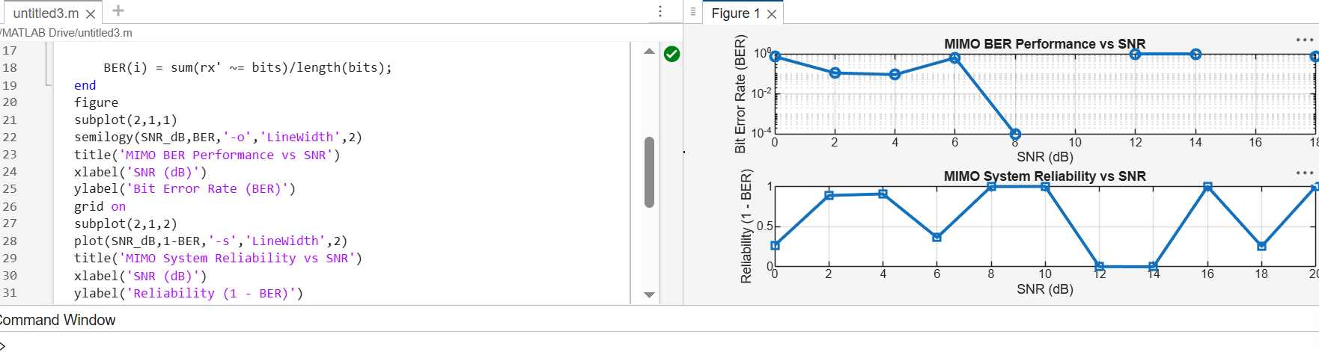
Objective 2 Matlab Code and Output:
clc; clear; close all;
% SNR range (dB)
SNR_dB = 0:2:20;
SNR = 10.^(SNR_dB/10);
% MIMO parameters
Nt = 2; Nr = 2;
% Simulated reliability metric (inverse BER model)
Reliability = zeros(1,length(SNR));
for i = 1:length(SNR)
% simple channel model effect
H = (randn(Nr,Nt) + 1j*randn(Nr,Nt))/sqrt(2);

noise_power = 1/SNR(i);

% reliability increases with SNR
Reliability(i) = 1 - exp(-SNR(i)/10);
end
figure
% -------- Graph 1: SNR vs Reliability --------
subplot(2,1,1)
plot(SNR_dB, Reliability, '-o', 'LineWidth', 2)
title('MIMO Reliability vs SNR')
xlabel('SNR (dB)')
ylabel('Reliability (0 to 1)')
grid on
% -------- Graph 2: SNR vs Noise Effect --------
subplot(2,1,2)
plot(SNR_dB, noise_power*ones(size(SNR_dB)), '-s', 'LineWidth', 2)
title('Noise Power Variation with SNR')
xlabel('SNR (dB)')
ylabel('Noise Power')
grid on
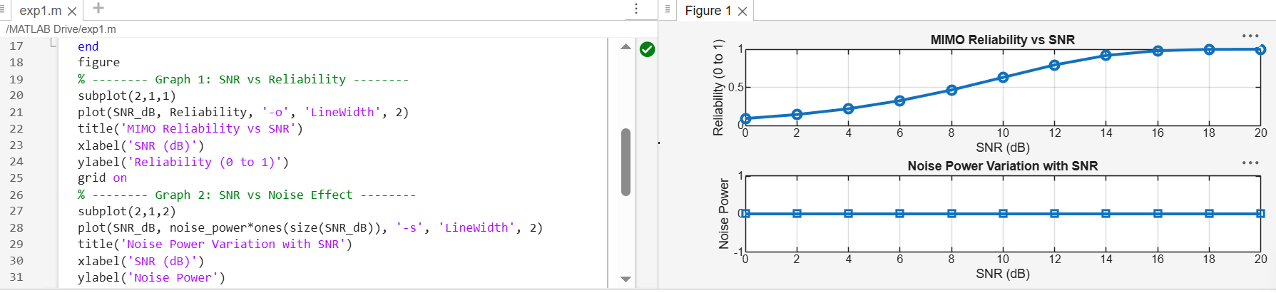
Objective 3 Matlab Code and Output:
clc; clear; close all;
rb_bw = 180e3;
users = 1:5;
alloc_RB = [10 12 8 15 5];
mod_eff = [2 4 6 4 2];
throughput = (alloc_RB .* rb_bw .* mod_eff) / 1e6;
disp('User Throughput (Mbps):')
disp(throughput')
figure
subplot(2,1,1)
plot(users, throughput, '-o','LineWidth',2)
title('OFDMA User Throughput')
xlabel('User Index')
ylabel('Throughput (Mbps)')
grid on
subplot(2,1,2)
plot(alloc_RB, throughput, '-s','LineWidth',2)
title('Resource Blocks vs Throughput')
xlabel('Allocated Resource Blocks')
ylabel('Throughput (Mbps)')
grid on
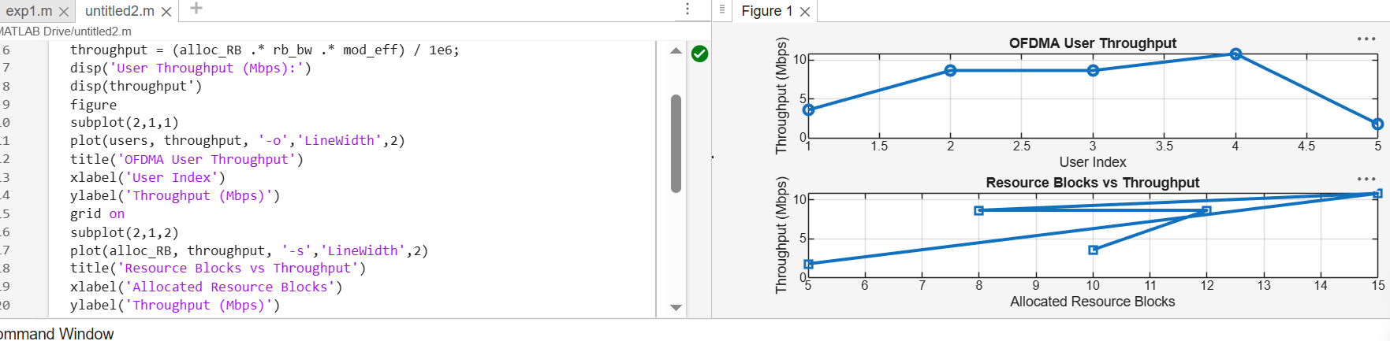
Result:
1. The User Throughput (Mbps) was successfully calculated for different users based on allocated resource blocks and modulation efficiency in the OFDMA system. 2. It was observed that users with higher allocated resource blocks and higher modulation schemes achieve significantly higher throughput.
3. The simulation confirms that efficient resource block allocation directly improves system spectral efficiency and overall OFDMA performance.

